**TASK 01:**

#include <iostream>

using namespace std;

int main() {

int ans = 0 , x,y;

for ( x = 2; x <= 50; x++) {

bool prime = true;

for ( y = 2; y < x; y++) {

if (x % y == 0) {

prime = false;

break;

}

}

if (prime==true) {

ans += x;

}

}

cout << "The sum of prime numbers between 1 and 50 is: " << ans << endl;

return 0;

}

**OUTPUT:**

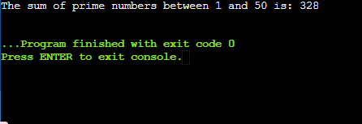

**TASK 02:**

#include <iostream>

using namespace std;

int main() {

for (int i = 1; i <= 5; i++) {

for (int j = 1; j <= i; j++) {

cout << j << " ";

}

cout << endl;

}

return 0;

}

**OUTPUT:**

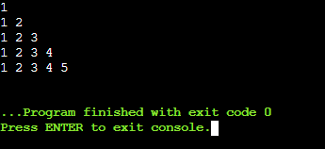

**TASK 03:**

#include <iostream>

using namespace std;

int main() {

int n = 2,a,b;

cout<<"1"<<endl;

for (int a = 1; a <= 6; a+=2) {

for (int b = 0; b <= a; b++) {

cout << n << " ";

}

n += 2;

cout << endl;

}

return 0;

}

**OUTPUT:**

